Instructions for registering in ORCID
The Association of Scientific Editors and Publishers in the methodological recommendations advise the authors to advance their articles before the publication. Much attention is paid to identifiers. In particular, ORCID ID allows accurately identifying the author and avoiding confusion in case of identical names. The personal area in the ORCID system also facilitates the process of tracking the author's publications.

The registration process is free. It takes a few minutes in many languages.

Click here to begin registartion: https://orcid.org/
You can choose your preferred language from the list of supported languages:
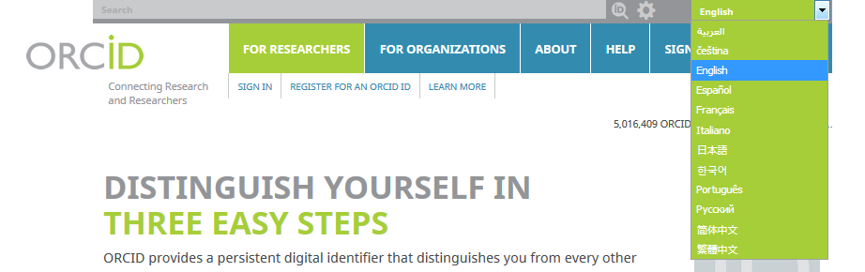

On the list "FOR RESEARCHERS" click the "Register for an ORCID iD" tab.

Fill the form fields and click the Register button:

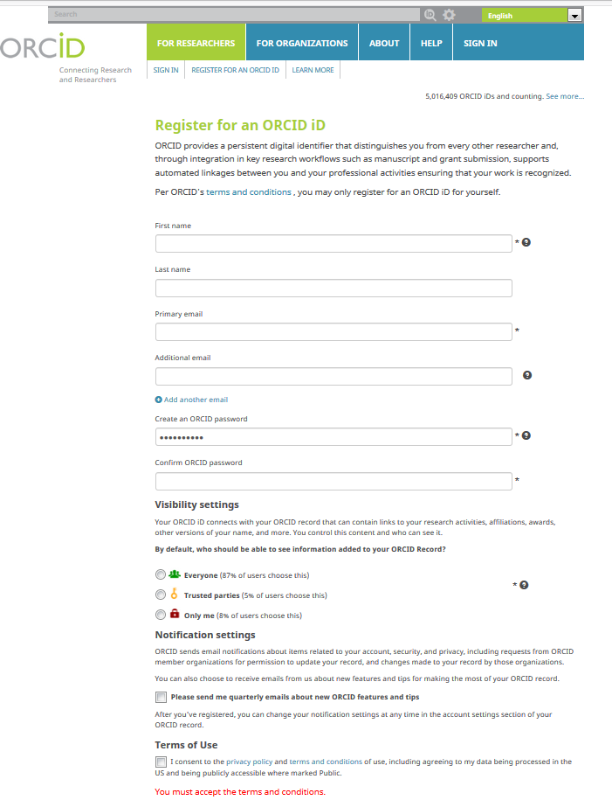
Then, you get your personal ORCID ID and can enter to your profile page in ORCID.

Your ORCID number is on the left, under your name. It has the format: http://orcid.org/0000-0000-0000-0000.
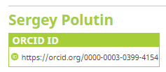
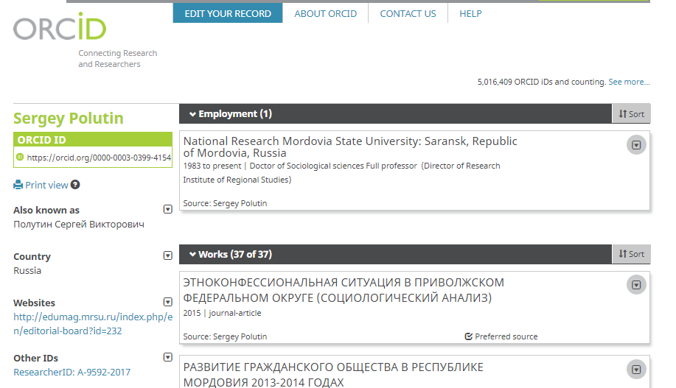
Add information about education and workplace in your ORCID record. Also you can load your research works on the profile page.
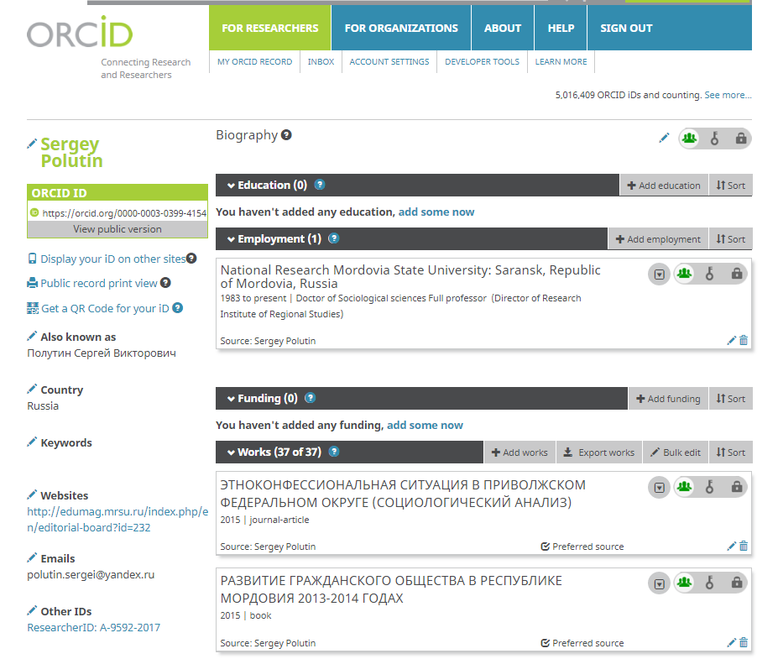

You can edit and add your personal data.

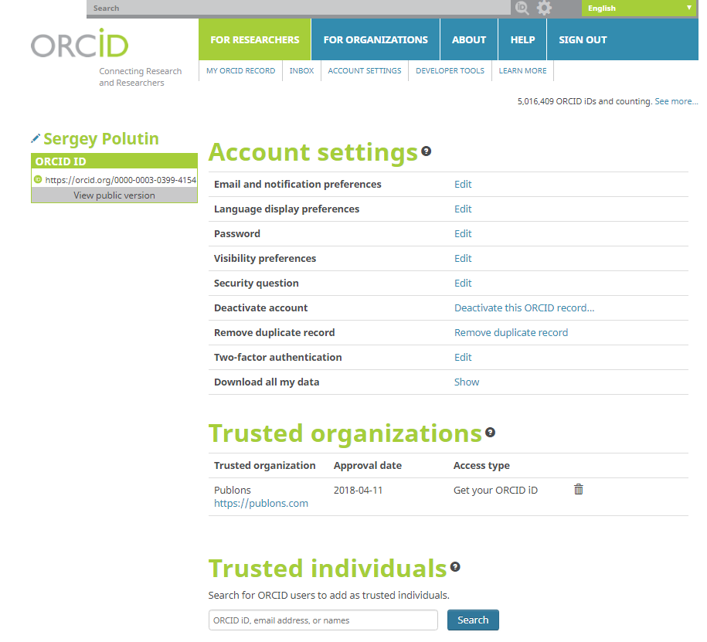

We recommend you to attach your ORCID indicators to submitting manuscripts, application documents for grants and other research processes.
Thanks for your activities.
Good luck with your research.

